Follow these steps to set up the software for the VeriStand hands on demo. You should have received the hardware preconfigured from your field engineer.

Step by step instructions:

1. Install NI VeriStand to your Windows computer
2. Run the NI VeriStand Hands On installer **for your operating system**
   * This will place all the hands on files on your computer in the appropriate directories.
   * The hands on doc will be placed on the desktop.
3. Verify the sbRIO is powered and connected to the R Series card.
   1. Port 1 of the R series card should be connected to the bottom left digital connector of the sbRIO, as shown:
   2. The bottom left LED of the four LEDs on the sbRIO should be blinking.

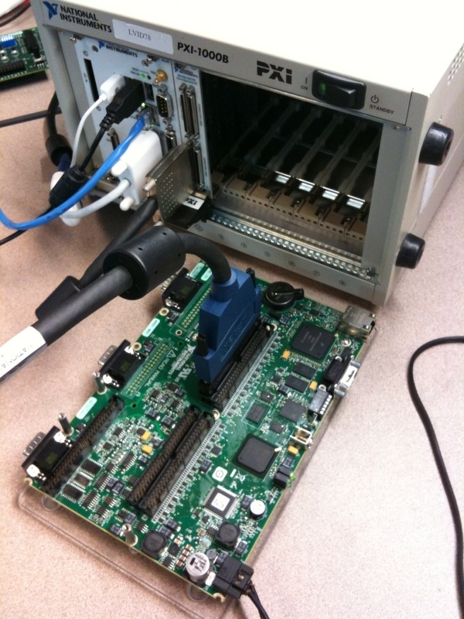

1. Double click the ‘NI VeriStand HandsOn.pdf’ shortcut on your desktop to start.